**Artificial Intelligence**

**Exp- 7 Uncertain Problem (Bayesian Belief Network)**

**Team Ai 4 life:**

Praneet Botke (RA1911031010149)

Adesh Sadekar (RA1911031010141)

Aayushi Goenka (RA1911031010151)

Sonia Raja (RA1911031010152)

Srinivasulu Kapuluru (RA1911031010142)

Sai Mohit Ambekar (RA1911031010137)

**Problem:**

Monty Hall Problem

**Problem statement:**

This is the Monty Hall problem. There are 3 doors in front of you, and there is a prize behind one of them. Once you select a door, I will open one of the two you had not selected which does not have a prize behind it. You will then have the opportunity to switch from the door you originally selected to an alternate door.

**Code:**

import random

A = "A"

B = "B"

C = "C"

doors = ["A", "B", "C"]

prize = random.choice(doors)

selection = input("Select door 'A', 'B', or 'C': ")

print("""

This problem relies on conditional probabilities.

It is suggested that you switch doors, you will have a higher probability

of winning of you do.""")

if selection == prize:

remaining = list(set(doors) - set(prize))

open_door = random.choice(list(set(doors) - set(random.choice(remaining))))

alternate = random.choice(list(set(doors) - set(open_door) - set(prize)))

else:

open_door = random.choice(list(set(doors) - set(selection) - set(prize)))

alternate = random.choice(list(set(doors) - set(open_door) - set(selection)))

print("""

The door I will now open is: %r

""" % open_door)

second_chance = input("Would you like to select the third door? Type 'Yes' or 'No': ")

if second_chance == "Yes":

print("""

The door you will switch to is: %r """ % alternate)

if alternate == prize:

print("""

Congrats, you win! The prize was behind the alternate, %r""" % alternate)

else:

print("""

Sorry, the prize was behind the original door %r""" % prize)

if second_chance != "Yes":

print("""

You decided to keep your initial door, %r""" % selection)

if selection != prize:

print("""

Sorry, the prize was behind the alternate door, %r""" % prize)

else:

print("""

Congrats, you win! The prize was behind your original

selection, %r""" % selection)

print("""

This is a check:""")

print("Prize: %r" % prize)

print("Selection: %r " % selection)

print("Alternate: %r " % alternate)

print("Door opened: %r " % open_door)

**Output:**

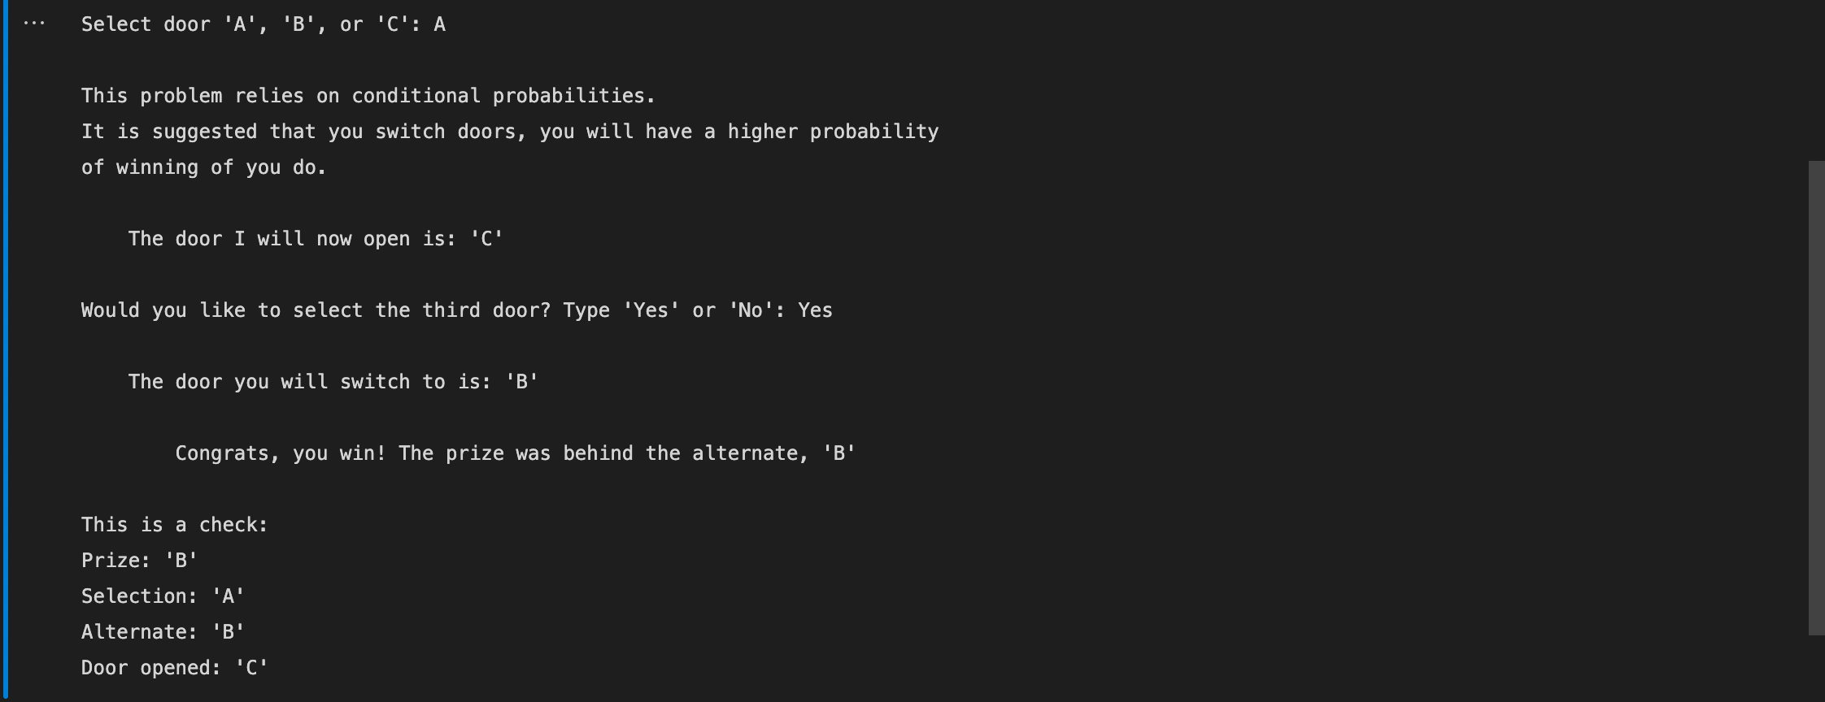

**Result:**

The problem statement for Uncertain Problem - Bayesian Belief Network(Monty Hall Problem ) is solved.